#### Prerequisites

|  |  |
| --- | --- |
| **Team ID** | **PNT2022TMID29193** |
| **Project Name** | **Smart Solutions for Railways** |

**INSTALLATION OF PYTHON 3.9.8**

Step 1: Type python in google and click on the first link



Step 2: Click the python 3.9.8

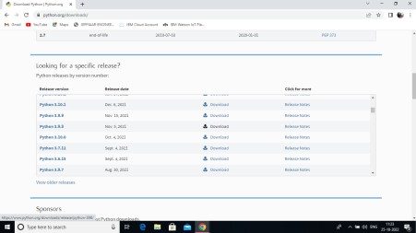

Step 3: Scroll down to reach Files and click on “Window installer (64 bit)

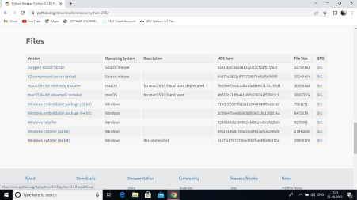

Step 4: Click on the Install button.

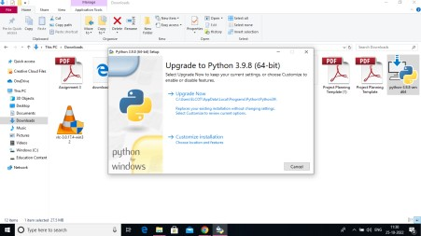

Step 5: Installation on progress

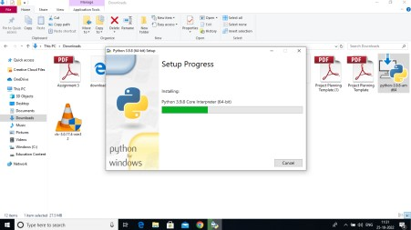

Step 6:Close the button

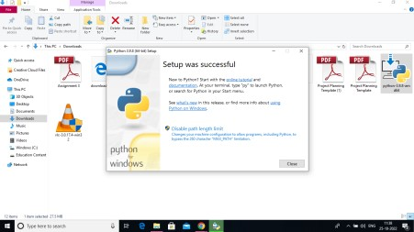

Step 7: Search IDLE

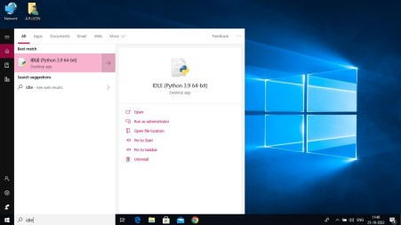

Step 8: Open it

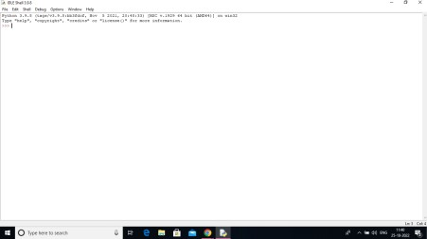

Step 9: Go to file and click on New File

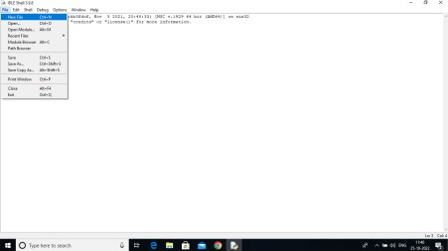

Step 10: Open it

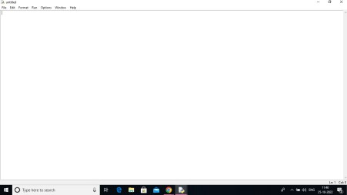

**Result:**

Python 3.9.8 is installed successfully.